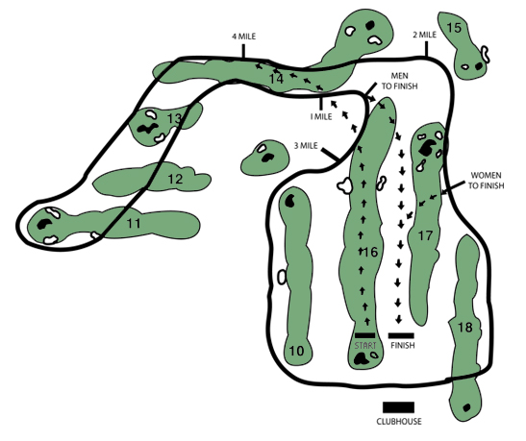
HS BOYS (2ND TIME) follow “TO FINISH”

HS GIRLS (2nd TIME) follow “TO FINISH”
Spectators please stay off the greens, tee boxes, and sand traps
No dogs or bikes are allowed on the golf course

